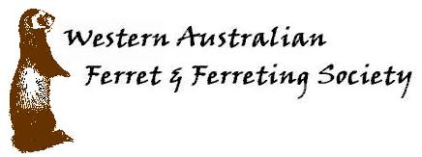

MEMBERSHIP APPLICATION FORM

Name Birthday

Name Birthday

Name Birthday

Name Birthday

Name Birthday

Address

Suburb Postcode

Phone/s Mobile

Email

Email newsletter in PDF format YES / NO

Please send form to  The Treasurer, WAFFS  PO Box 382  Greenwood WA 6024  Or  Email mail@waffs.org.au  Advise of direct transfer | Fees  New members $30.00  Renewals $25.00  Please make cheques / money orders payable to:  “WA Ferret Society”  Direct bank transfer.  B Bank details: WA Ferret Society Inc.  A BSB 066160 Account number 11086394  Include your name in the details

About WAFFS
The Western Australian Ferret & Ferreting Society is the oldest and largest ferret welfare organisation in Australia. Founded in 1981, our club has members in all states of Australia as well as overseas. Our main reason for being is to provide education and assistance to our members and the general public on the health and welfare of ferrets.
A wide range of services is available to our members, so become a member today!

If you require any further details about our Society, please phone 1300 133 323, or see our web site www.waffs.org.au

